UCD DISTRIBUTED SYSTEM LAB 3

Kartikeya Sharma
25201462
Github_url : https://github.com/savagecarol/ucd_distributed_system_lab_4
Step 1 : Implementation of Backend-Service in GO-LANG
1. Use go-lang so that it can decrease the image size.
2. Implemented 3 apis (/heath , /api/first/, /api/second)
3. Use gin framework to implement APIS
4. I created the image and name it as my-go-server
5. Implemented API - in that way that they generate Chaos Testing Scenario
SCREENSHOTS RELATED TO BACKEND-SERVICE
a. Code
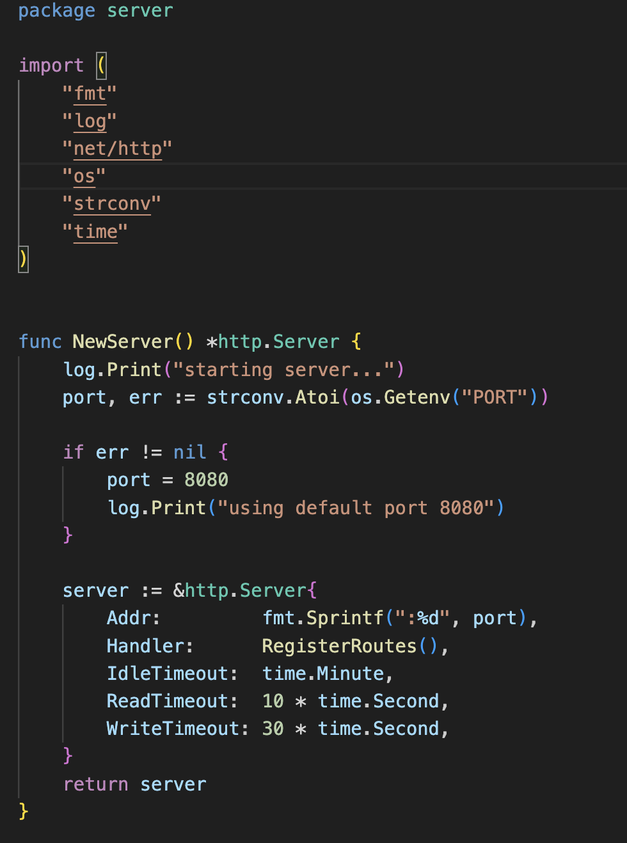
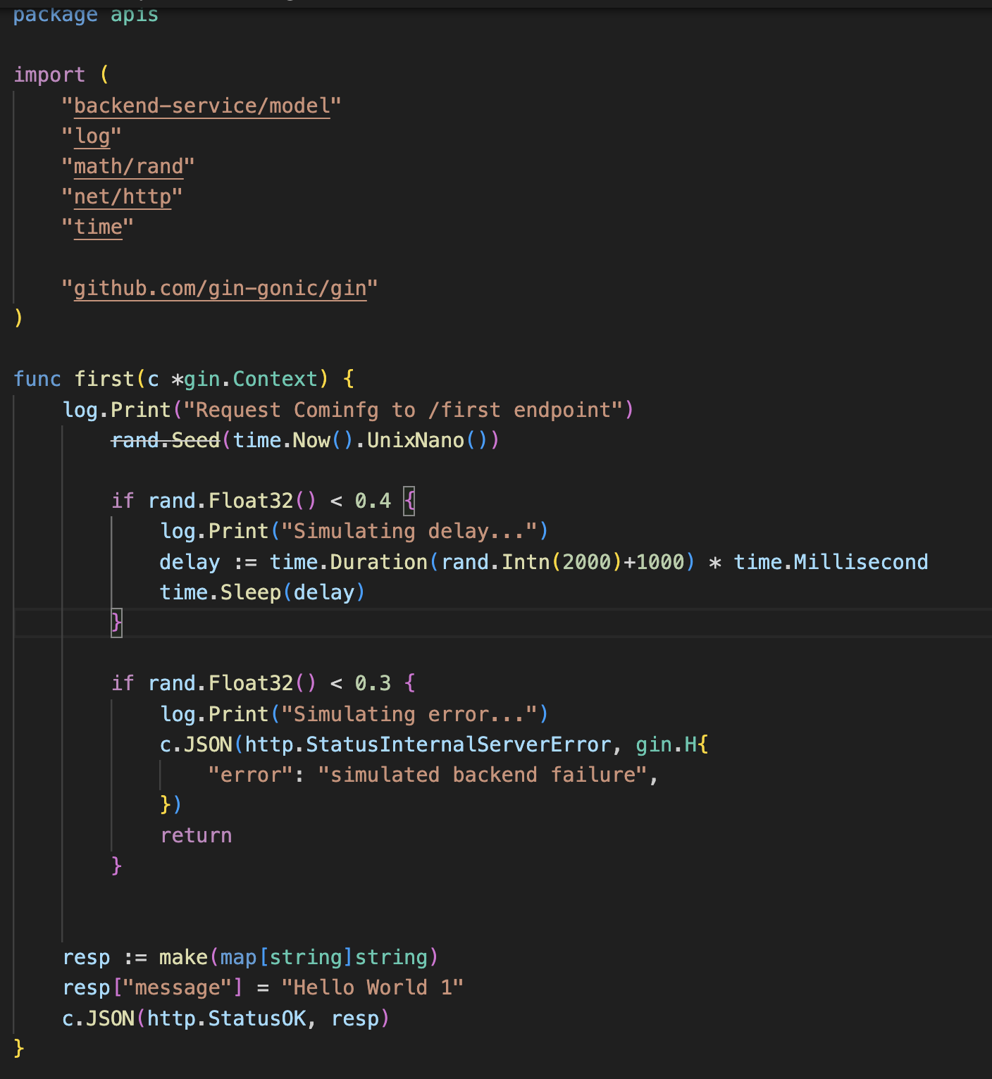

b. Docker File
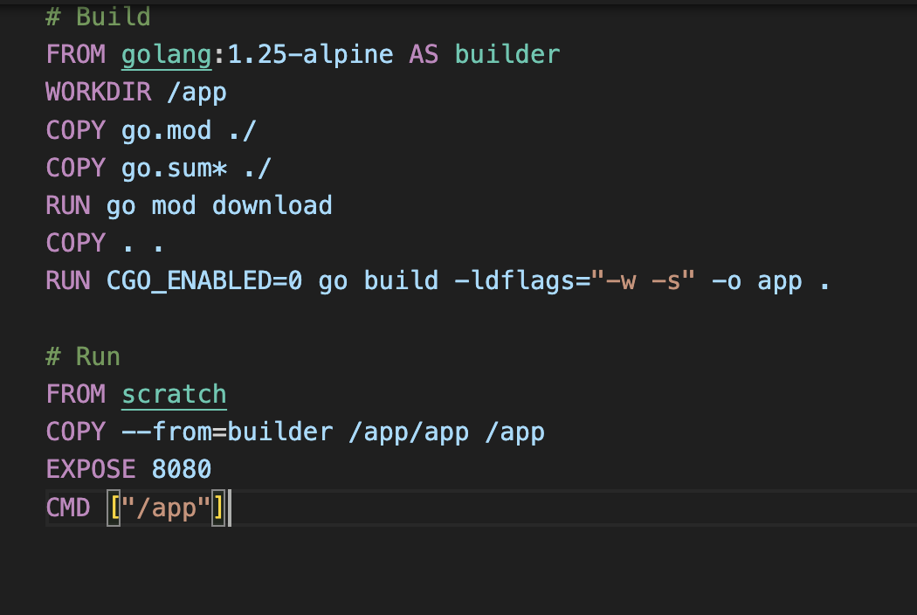

Step 2 : Deploy on Kubernetes with Minikube
1. Add image to minikube
2. Run kubernetes-deployment.yaml
3. I created 3 replica and 1 load balancer
4. Checking /health api to see pods are healthy or not
5. Commands that i am using

a) minikube image load my-go-server:v1
b) kubectl apply -f kubernetes-deployment.yaml
c) kubectl get pods
d)kubectl logs -l app=go-server -f --prefix=true
e) minikube service go-server-service --url
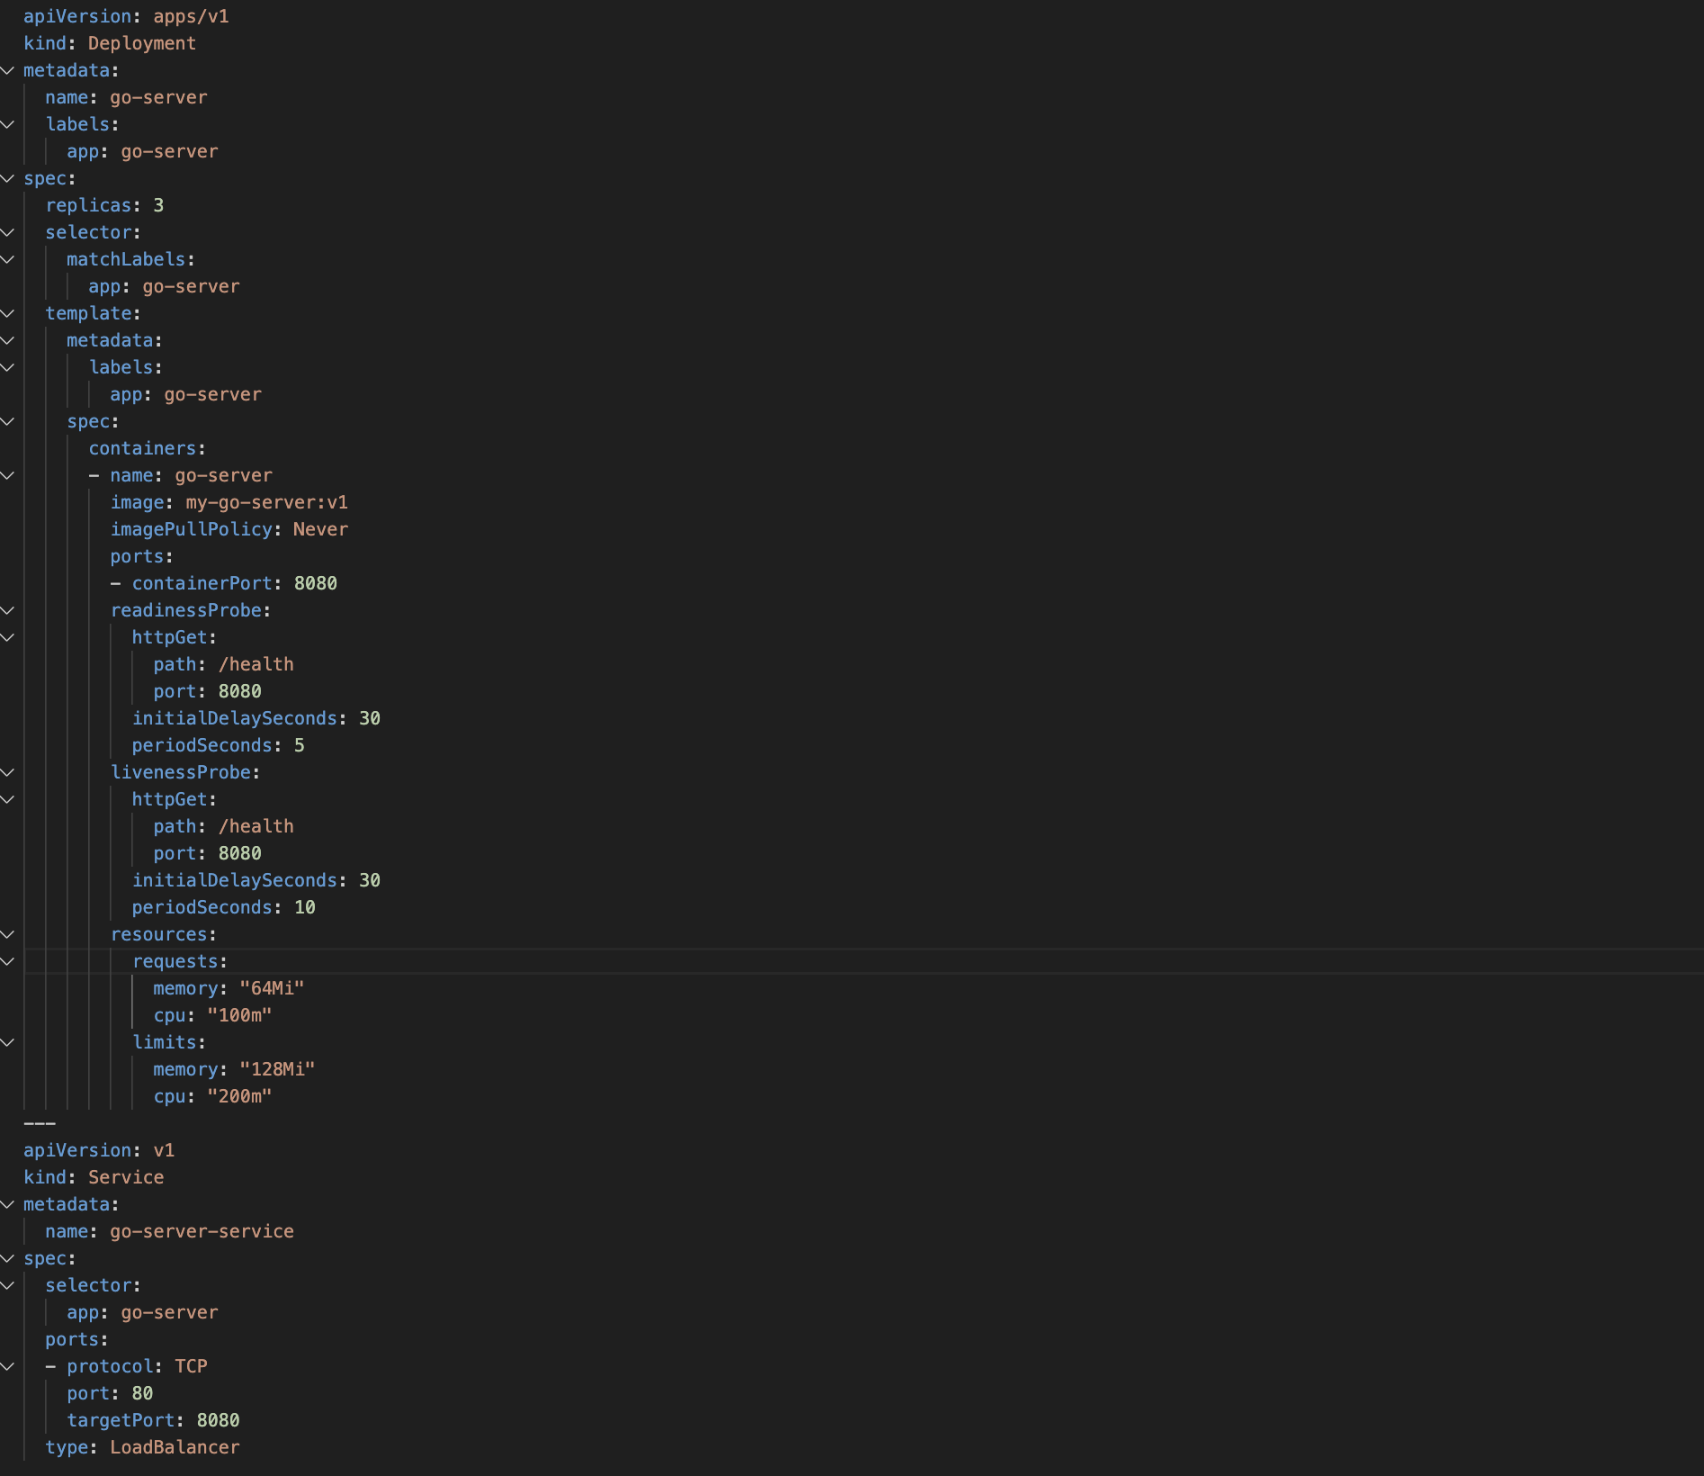

Step 3 : Client Code to Implement Circuit Breaker Jitter Chaos Testing
1. Client code is written in python
2. Using library pybreaker and tenancy
3. Circuit Breaker with small configuration (fail_max = 1, closed for .01 sec) - to generate scenarios and 4 retry.
4. Run the scenario 600 times for testing to generate every scenario
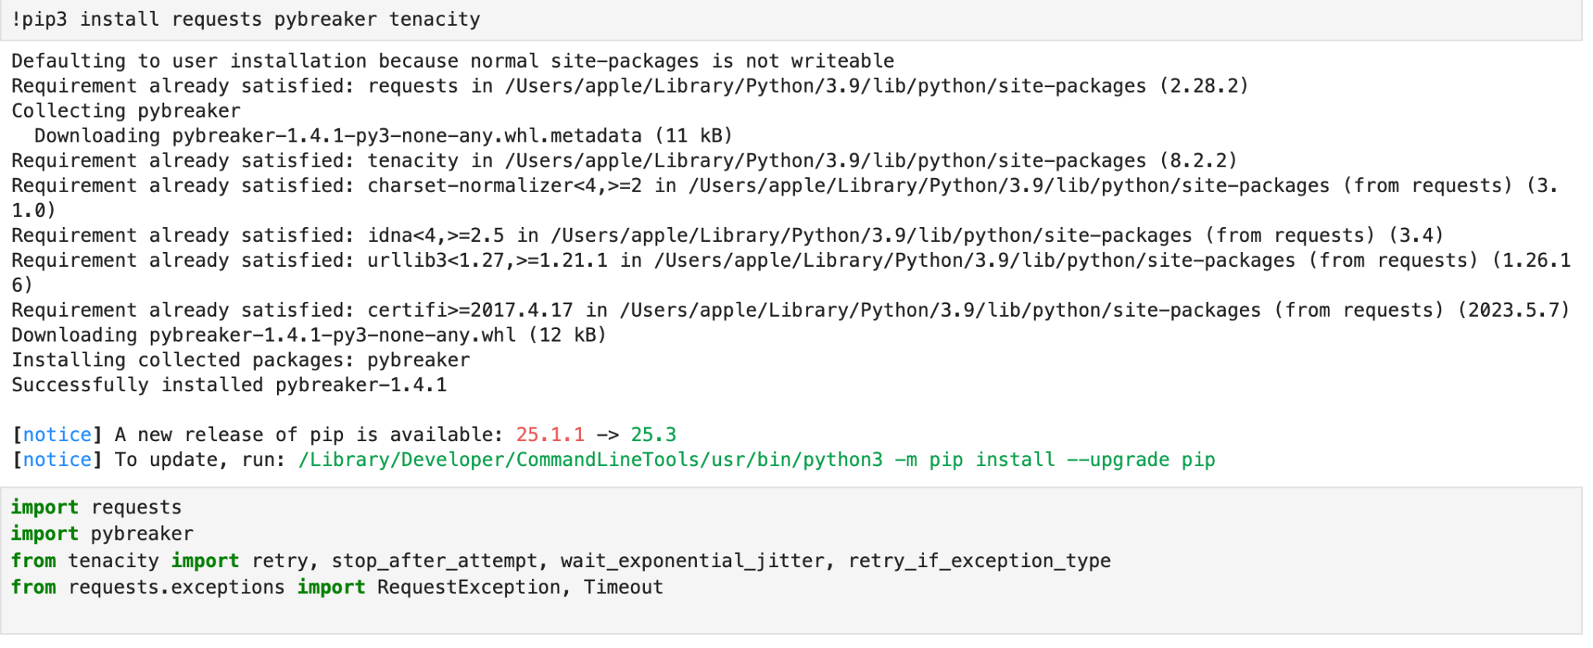

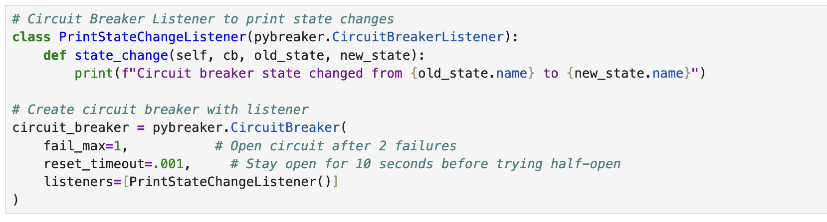

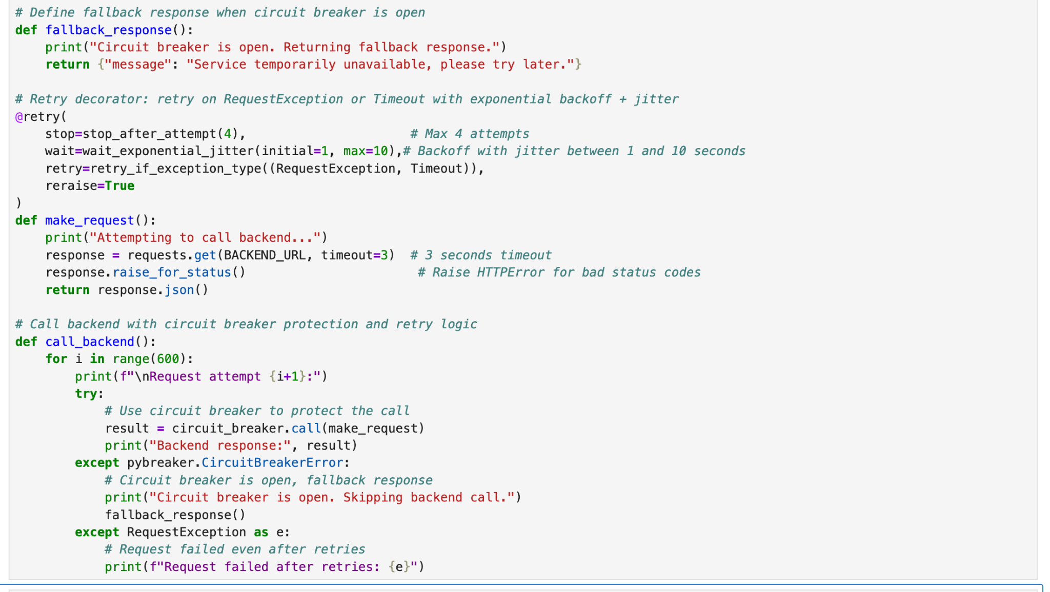
RESULTS:
- Retry: in attempt 9 result come in one time but in attempt 10 2 times retry.

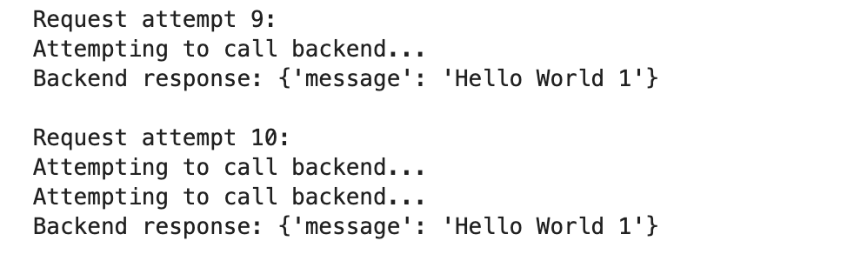

- Circuit Breaker Started and changing it State.
Attempt: 7 -> working perfectly
Attempt 8 -> retries then it reaches to circuit breaker
Attempt 9 -> lies in .1 second (Fallback is working)
Attempt 11 and 12-> again working perfectly
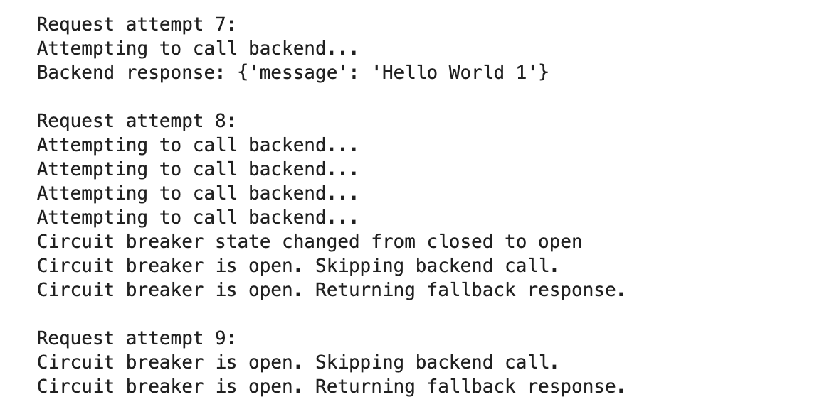
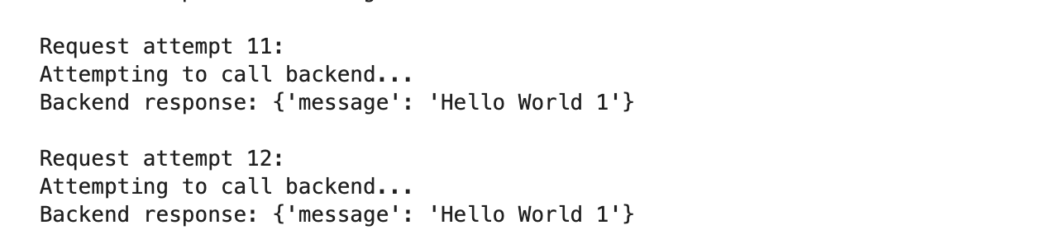
- Chaos yaml -> achieved by chaos.yaml with helm
And i also added errors in /api/first
- Results are going to be same as point 2
- In api/first we are generating errors by ourself

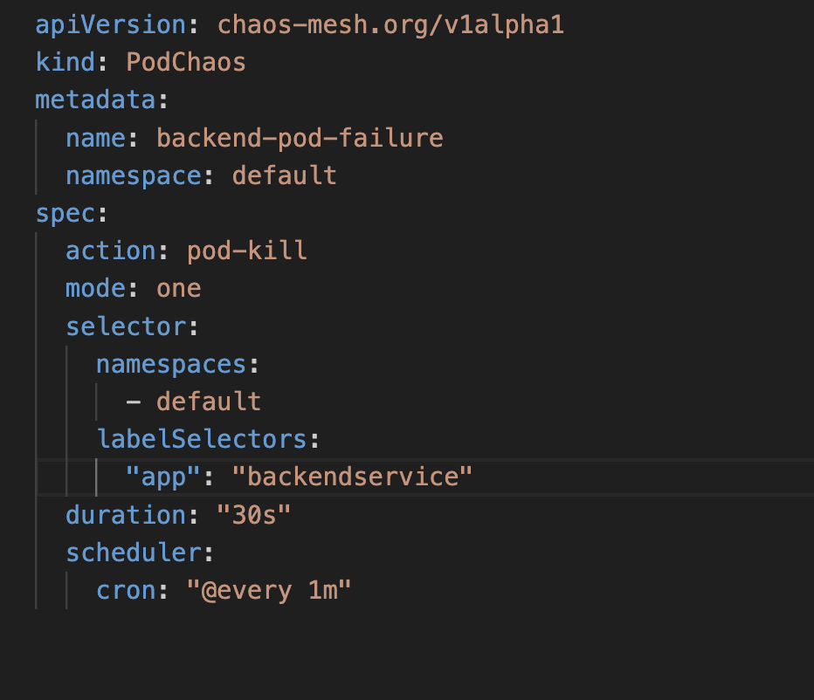

4. To increase the latency in the response i Run the postman and i done change in the API for that.
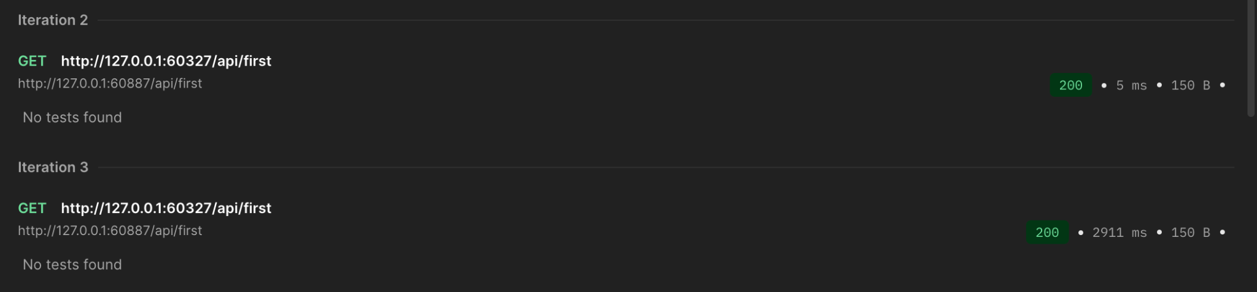

CONCLUSIONS:
Distributed systems are prone to failures such as network issues, crashes, and slow responses; designing for resilience is essential.
- Implementing Circuit Breakers helped prevent client overload during persistent backend failures by quickly failing and using fallback responses.
- Using Retries with Exponential Backoff and Jitter allowed automatic recovery from transient errors while avoiding retry storms.
- The resilience patterns improved system availability, fault tolerance, and maintained responsiveness under failure conditions.
- Chaos engineering experiments simulated real failures like pod crashes and network partitions, validating the effectiveness of the resilience mechanisms.
- The system gracefully handled partial failures and recovered smoothly during chaos tests, demonstrating practical fault tolerance.
- Trade-offs between latency, complexity, and availability were observed, highlighting the need to balance these factors based on system requirements.
- Overall, the lab reinforced that resilience must be built into distributed systems architecture proactively, not just added reactively.
- Combining resilience patterns with chaos testing provides a strong approach to designing reliable and observable distributed applications.

